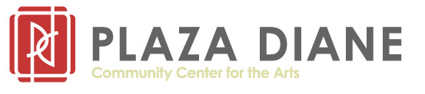
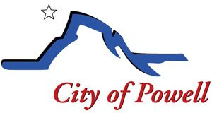
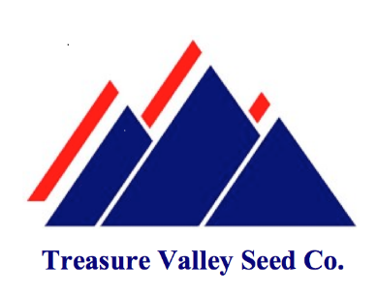

2023 Bean Mill Mural Design Competition

Mural Guidelines and Review Criteria
Project Goals:
- To produce a new mural for the Powell Bean Mill that is representative of the community.
- To promote and celebrate the cultural value of our community.
- To enhance the Highway 14A frontage and downtown business area.
General Guidelines:
These guidelines detail how to participate in Powell’s 2023 Bean Mill Mural Design Competition. The process is intended to safeguard the interests of the applicant, the community, and the building/property owner.
The Park County Travel Council has granted the City of Powell funding for production of a new mural to replace the current John Wesley Powell image on the Powell Bean Mill. Additional fundraising will be done to complete installation and lighting for the project. The city is partnering with Plaza Diane Community Center for the Arts to conduct the Mural Design Competition.

Artwork should be scaled to fit the bean mill mural surface (see attached diagram) owned by Treasure Valley Seed. If selected, the design will be reproduced by a professional painting company in sections and installed by contractors. The winning artist will have an opportunity to sign the mural upon completion.

Mural Criteria:
- All applicants must be aged 14 or older to enter the competition; individuals aged 14-17 will require the signature of a parent/guardian.
- Artwork submissions must be original work (concept, design, and execution) of the person named in the entry form. Artwork submissions will not be returned.
- The mural design should be inspired by Powell: the land, history, and community/people.
- Artists may submit multiple design proposals but will need to submit a separate application and scaled color rendering of the proposed design for each entry (using the attached diagram).
- A cash award of $250 will be provided for the winning design.
- Artists will be notified of the selected design and winner.

Application, Review and Winning Design Selection Process
Entries will be judged without identification, so the panel is blind to the individual artists. Scoring will be based on originality, creativity, quality, and subject matter relevant to the Powell community.
Projects that do not meet the design criteria/guidelines may be eliminated from the competition. Moreover, Treasure Valley Seed, Plaza Diane and the City of Powell reserve the right to accept or reject any or all entries.

Schedule
Activity | Date
Release of Contest Details/Open Call for Artists | September 1, 2023
Application Period | September 1 – 29, 2023
Mural Design Review by Selection Committee | October 2 – 12, 2023
Announcement of Selected Design | October 13, 2023
Mural Installation | Summer 2024

Ownership Rights
Once submitted, the artist agrees to have their design displayed by Plaza Diane Community Center for the Arts. No fee or other compensation will be remitted to the artist of the winning mural design for its use in ongoing publicity activities. Photos of the mural may be used freely throughout marketing for Treasure Valley Seed, the City of Powell, Plaza Diane, and other entities for general community promotion.

The deadline for entry is September 29, 2023. Submit this form and a PDF/JPG of your design to Plaza Diane at plazadiane@gmail.com, or deliver them to 211 N Bent St/PO Box 1292, Powell, WY 82435.
Questions? Email Katie Stensing at Plazadiane@gmail.com; (307) 271-1264.
Don’t miss this opportunity to have YOUR art on display for Powell residents and visitors to enjoy!

